**PIZZA SALES SQL QUERIES**

**A. KPI’s**

**1. Total Revenue:**

Select sum(total_price) Toal_Revenue from pizza_sales;

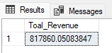

**2. Average Order Value**

Select Sum(total_price) / Count(Distinct order_id) Average_Order_Value from pizza_sales;

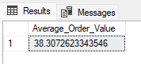

**3. Total Pizzas Sold**

Select Sum(quantity) Total_Pizza_Sold from pizza_sales;

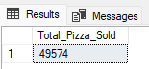

**4. Total Orders**

Select Count(Distinct order_id) Total_order from pizza_sales;

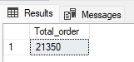

**5. Average Pizzas Per Order**

Select Cast(Cast(Sum(quantity) AS Decimal (10,2)) / Cast(Count(Distinct order_id) AS Decimal(10,2)) As Decimal(10,2)) Average_Pizzas_per_Order fROM pizza_sales;

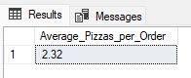

**B. Daily Trend for Total Orders**

Select DATENAME(DW,order_date) Order_Day, Count(Distinct order_id) Total_Orders from pizza_sales

Group By DATENAME(DW,order_date);

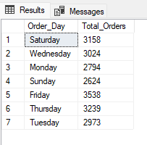

**C. Monthly Trend for Orders**

Select DATENAME(Month,order_date) Order_Month, Count(Distinct order_id) Total_Orders from pizza_sales

Group By DATENAME(Month,order_date);

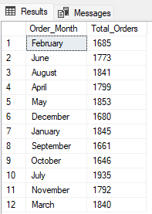

**D. % of Sales by Pizza Category**

Select pizza_category, Cast(Sum(total_price)*100 / (Select Sum(total_price) from pizza_sales) AS Decimal(10,2)) Percentage_Pizza_Category from pizza_sales

Group By pizza_category;

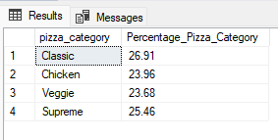

**E. % of Sales by Pizza Size**

Select pizza_size, Cast(Sum(total_price)*100 / (Select Sum(total_price) from pizza_sales) As Decimal(10,2)) Percentage_Pizza_Size from pizza_sales

Group By pizza_size;

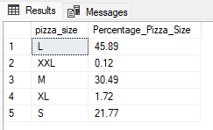

**F. Total Pizzas Sold by Pizza Category**

Select pizza_category, Sum(quantity) Total_Pizza_by_Category From pizza_sales

Group By pizza_category;

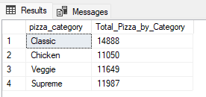

**G. Top 5 Pizzas by Revenue**

Select Top 5 pizza_name, Cast(Sum(total_price) AS Decimal(10,2)) Total_Revenue from pizza_sales

Group By pizza_name

order by Sum(total_price) desc;

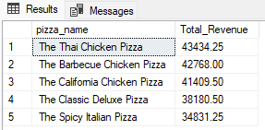

**H. Bottom 5 Pizzas by Revenue**

Select Top 5 pizza_name, Cast(Sum(total_price) AS Decimal(10,2)) Total_Revenue from pizza_sales

Group By pizza_name

order by Sum(total_price) Asc;

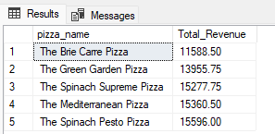

**I. Top 5 Pizzas by Quantity**

Select Top 5 pizza_name, Sum(quantity) Total_Quantity from pizza_sales

Group By pizza_name

Order By Sum(quantity) Desc;

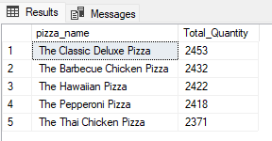

**J. Bottom 5 Pizzas by Quantity**

Select Top 5 pizza_name, Sum(quantity) Total_Quantity from pizza_sales

Group By pizza_name

Order By Sum(quantity) Asc;

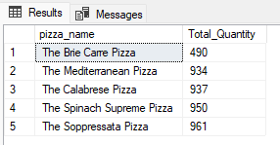

**K. Top 5 Pizzas by Total Orders**

Select Top 5 pizza_name, Count(DISTINCT order_id) Total_Orders from pizza_sales

Group By pizza_name

Order By Total_Orders Desc;

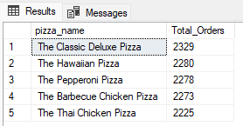

**L. Bottom 5 Pizzas by Total Orders**

Select Top 5 pizza_name, Count(DISTINCT order_id) Total_Orders from pizza_sales

Group By pizza_name

Order By Total_Orders Asc;

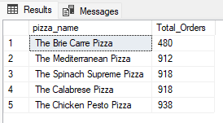

**K. Top 5 Pizzas by Total Orders by Classic Category**

Select Top 5 pizza_name, Count(DISTINCT order_id) Total_Orders from pizza_sales

Where pizza_category = 'Classic'

Group By pizza_name

Order By Total_Orders Desc

